*How does the web work?*

The WEB (World Wide Web)is a way of accessing information through the medium of the Internet. It is an information-sharing model that is built on top of the Internet.

Computers connected to the web are called **clients** and **servers**. A simplified diagram of how they interact might look like this:

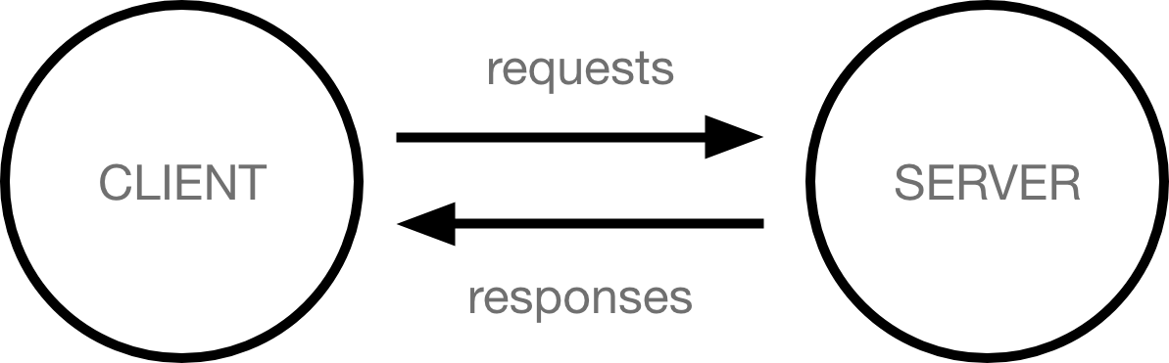

* Clients are the typical web user's internet-connected devices (for example, your computer connected to your Wi-Fi, or your phone connected to your mobile network) and web-accessing software available on those devices (usually a web browser like Firefox or Chrome).
* Servers are computers that store webpages, sites, or apps. When a client device wants to access a webpage, a copy of the webpage is downloaded from the server onto the client machine to be displayed in the user's web browser.

When you type a web address into your browser (for our analogy that's like walking to the shop):

1. The browser goes to the DNS server, and finds the real address of the server that the website lives on (you find the address of the shop).
2. The browser sends an HTTP request message to the server, asking it to send a copy of the website to the client (you go to the shop and order your goods). This message, and all other data sent between the client and the server, is sent across your internet connection using TCP/IP.
3. If the server approves the client's request, the server sends the client a "200 OK" message, which means "Of course you can look at that website! Here it is", and then starts sending the website's files to the browser as a series of small chunks called data packets (the shop gives you your goods, and you bring them back to your house).
4. The browser assembles the small chunks into a complete web page and displays it to you (the goods arrive at your door — new shiny stuff, awesome!).

*What*do you need*to be a web developer?*

To become a web developer, I need an enhancing environment which serves me the creativity and the motivation. Then, I should have an understanding of HTML, CSS, and JavaScript. Developing these fundamental web development skills will give me the foundation and logic for communicating with programming languages. In addition, I should work on projects to develop my skills and I should build a good portfolio.

*What*is the role of *a web developer?*

The role of a web developer is to have a responsibility for designing, coding and uploading the websites. In addition, he should respect a client’s specifications. Besides, a web developer should create visually appealing sites that feature user-friendly design and clear navigation.